SWIGGY SALES ANLYSIS
DATA ANALYSIS QUERY DOCUMENT

KPI Development
Once the schema is built, compute core performance indicators:
Basic KPIs
- Total Orders
SELECT COUNT(*) AS Total_Orders FROM fact_swiggy_orders;

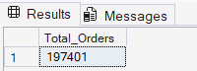

- Total Revenue (INR Million)
SELECT
FORMAT(SUM(CONVERT(FLOAT,price_INR))/1000000, 'N2') + 'INR Million'
AS Total_Revenue
FROM fact_swiggy_orders;

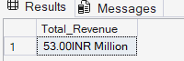

- Average Dish Price
SELECT
FORMAT(AVG(CONVERT(FLOAT,price_INR)), 'N2') +'INR'
AS Total_Revenue
FROM fact_swiggy_orders;

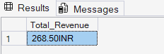

- Average Rating
SELECT
AVG(Rating) AS Avg_Rating
FROM fact_swiggy_orders;

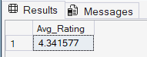

Deep-Dive Business Analysis
Date-Based Analysis
- Monthly trends
SELECT
d.year,
d.month,
d.month_name,
COUNT(*) AS TOTAL_ORDER,
SUM(Price_INR) AS TOTAL_REVENUE
FROM fact_swiggy_orders AS f
JOIN dim_date AS d
ON f.date_id = d.date_id
GROUP BY d.year,d.month,d.month_name;

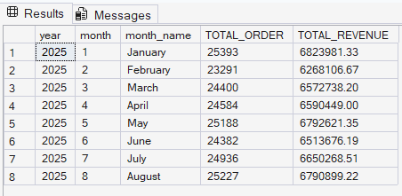

- Quarterly trends
SELECT
d.year,
d.Quarter,
COUNT(*) AS TOTAL_ORDER,
SUM(Price_INR) AS TOTAL_REVENUE
FROM fact_swiggy_orders AS f
JOIN dim_date AS d
ON f.date_id = d.date_id
GROUP BY d.year,d.Quarter;

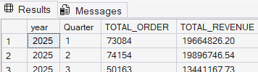

- Year-wise growth
SELECT
d.year,
COUNT(*) AS TOTAL_ORDER,
SUM(Price_INR) AS TOTAL_REVENUE
FROM fact_swiggy_orders AS f
JOIN dim_date AS d
ON f.date_id = d.date_id
GROUP BY d.year;

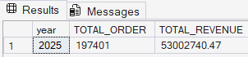

- Day-of-week patterns
-- Orders by Day of Week (Mon-Sun)
SELECT
DATENAME (WEEKDAY, d.full_date) AS day_name,
COUNT(*) AS total_orders
FROM fact_swiggy_orders AS f
JOIN dim_date AS d ON f.date_id = d.date_id
GROUP BY DATENAME (WEEKDAY, d.full_date), DATEPART(WEEKDAY, d.full_date)
ORDER BY DATEPART(WEEKDAY, d.full_date);

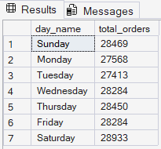

Location-Based Analysis
- Top 10 cities by order volume
SELECT TOP 10
l.city,
COUNT(*) AS Total_orders
FROM fact_swiggy_orders AS f
JOIN dim_location AS l
ON l.location_id = f.location_id
GROUP BY l.city
ORDER BY COUNT(*) DESC;

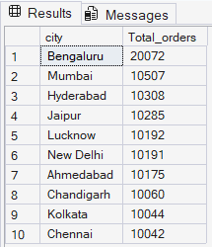

- Top 10 cities by Revenue
SELECT TOP 10
l.city,
SUM(Price_INR) AS TOTAL_REVENUE
FROM fact_swiggy_orders AS f
JOIN dim_location AS l
ON l.location_id = f.location_id
GROUP BY l.city
ORDER BY SUM(Price_INR) DESC;

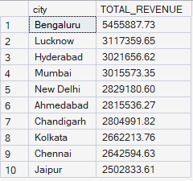

- Revenue contribution by states
SELECT
l.State,
SUM(Price_INR) AS TOTAL_REVENUE
FROM fact_swiggy_orders AS f
JOIN dim_location AS l
ON l.location_id = f.location_id
GROUP BY l.State
ORDER BY SUM(Price_INR) DESC;

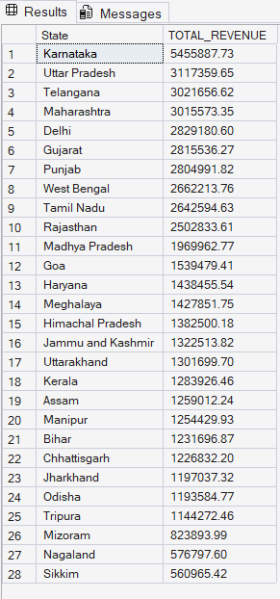
Food Performance
- Top 10 restaurants by orders
SELECT TOP 10
r.Restaurant_Name,
COUNT(*) AS TOTAL_ORDERS
FROM fact_swiggy_orders AS f
JOIN dim_restaurant AS r
ON r.restaurant_id = f.restaurant_id
GROUP BY r.Restaurant_Name
ORDER BY SUM(Price_INR) DESC;

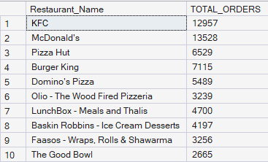

- Top categories (Indian, Chinese, etc.)
SELECT TOP 10
c.category,
COUNT(*) AS total_orders
FROM fact_swiggy_orders f
JOIN dim_category c ON f.category_id = c.category_id
GROUP BY c.category
ORDER BY total_orders DESC;

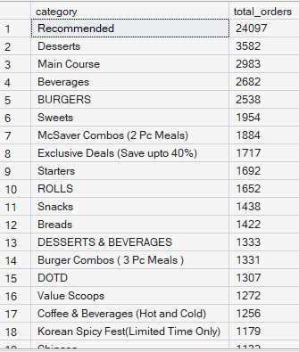

- Most ordered dishes
SELECT TOP 10
d.dish_name,
COUNT(*) AS order_count
FROM fact_swiggy_orders f
JOIN dim_dish d ON f.dish_id = d.dish_id
GROUP BY d.dish_name
ORDER BY order_count DESC;

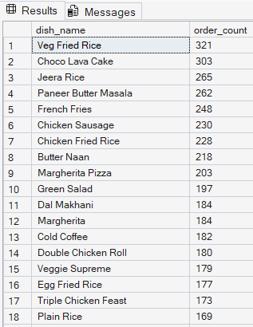

- Cuisine performance → Orders + Avg Rating
SELECT
c.category,
COUNT(*) AS total_orders,
AVG( f.rating) AS avg_rating
FROM fact_swiggy_orders f
JOIN dim_category c ON f.category_id = c.category_id
GROUP BY c.category
ORDER BY total_orders DESC;
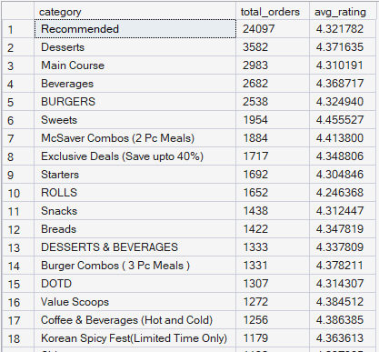

Customer Spending Insights
Buckets of customer spend:
- Under 100
- 100–199
- 200–299
- 300–499
- 500+
With total order distribution across these ranges.

SELECT
CASE
WHEN CONVERT(FLOAT, price_inr) < 100 THEN 'Under 100'
WHEN CONVERT(FLOAT, price_inr) BETWEEN 100 AND 199 THEN '100 - 199'
WHEN CONVERT(FLOAT, price_inr) BETWEEN 200 AND 299 THEN '200 - 299'
WHEN CONVERT(FLOAT, price_inr) BETWEEN 300 AND 499 THEN '300 - 499'
ELSE '500+'
END AS price_range,
COUNT(*) AS total_orders
FROM fact_swiggy_orders
GROUP BY
CASE
WHEN CONVERT(FLOAT, price_inr) < 100 THEN 'Under 100'
WHEN CONVERT(FLOAT, price_inr) BETWEEN 100 AND 199 THEN '100 - 199'
WHEN CONVERT(FLOAT, price_inr) BETWEEN 200 AND 299 THEN '200 - 299'
WHEN CONVERT(FLOAT, price_inr) BETWEEN 300 AND 499 THEN '300 - 499'
ELSE '500+'
END
ORDER BY total_orders DESC;

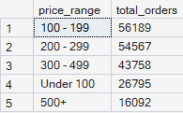

Ratings Analysis
Distribution of dish ratings from 1–5.
SELECT
rating,
COUNT(*) AS rating_count
FROM fact_swiggy_orders
GROUP BY rating
ORDER BY COUNT(*) DESC;

